Event Management System

**Event Management System**

• Develop an event management application in Java that allows users to create, view, and register for events, as well as track event attendance.

• Use collections for managing event attendees, file handling for storing event details, and JDBC for data persistence.

**Step-by-Step Problem Breakdown:**

**1. Core Classes:**

o Define Event, Attendee, and Ticket classes.

**2. Inheritance and Polymorphism:**

o Different event types (e.g., Concert, Conference) with specific ticketing rules.

**3. Encapsulation and Abstraction:**

o Interfaces for managing events, like registerEvent, buyTicket.

**4. Collections:**

o Use ArrayList to manage attendees and event tickets.

**5. Core Functionalities:**

o Register for events, purchase tickets, and view event details.

**6. Exception Handling:**

o Handle overbooked events and duplicate registrations. 7. File Handling:

o Save event and attendee data.

**8. JDBC:**

o Store event and registration data in a database.

**9. User Interface:**

o Menu

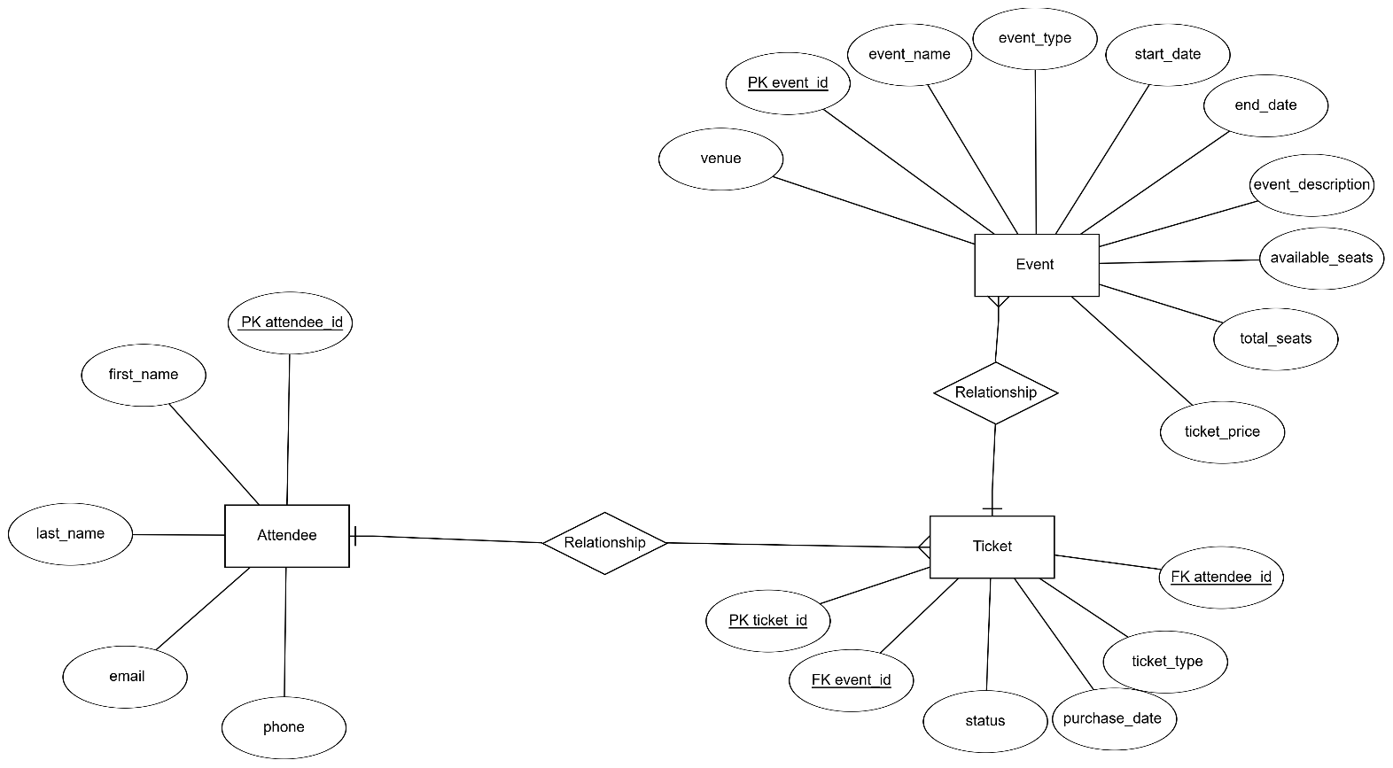**ER DIAGRAM:**

**CLASS DIAGRAM:  
  
